LOGO DESIGN AGREEMENT
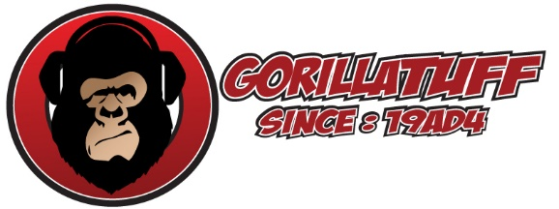
Cell: (678) 392-7468
Email: gorillatuff84.com
Designer agrees to the following:
I agree to create a custom logo design suitable for your business identity and satisfactory to you. I promise to deliver your finished logo design in digital image files of high enough quality to be printed on business related print goods and for web page display when I have been paid in full.
Details:
Logo Concepts and First Viewing: Within seven business days of receiving your company info, and receiving a 50% deposit, I will create up to four different logo concepts for you. When I have received your feedback on these designs I will make any needed changes to your logo choice.
File Delivery:
After the final logo design is approved I agree to deliver the logo design to you as digital files (.png, .gif, .pdf, .ai., .eps, and/or .jpg graphics file formats). Custom logo packages are delivered to you by email or if the files are very large, you will be given a private link to download a zipped folder of all your files.
Ownership:
I give you the right to use your new logo design in all media useful for your business promotion. I ask that you let me display your new Logo Image and your full name, business name, and website address or company address, for testimonial and promotional purposes in my printed and online portfolios and in printed ads.
Originality:
I affirm that my Logo Designs are original and that I own the rights granted under this agreement, and that the rights granted do not conflict any other agreement.
Client’s part of the agreement:
In return for the above-described logo design, Client agrees to pay the total fee payable in two payments. A logo fee deposit before any work begins and the remaining payment when final logo design is approved.
Ownership:
I understand that the final Logo Design belongs to Gorilla Tuff until I have paid in full. In the event of termination of this Agreement, Gorilla Tuff owns the Logo and has the right to complete, exhibit, and/or sell the Logo Design if she so chooses. She also owns all the logo design concepts created.
Use of Logo:
I understand that once I have paid in full that I have the right to use the Logo Design in all media useful for business promotion and that Gorilla Tuff reserves the right to display the logo in portfolios and promotional displays (example: logo designs on websites or printed on flyers).
It is also up to me to do a Trademark search and federal trademark registration if I want to register my Logo as my company Trademark. (Start here to learn more about Trademarks: http://www.uspto.gov/main/trademarks.htm )
Termination: I have the right to terminate this Agreement if, Gorilla Tuff fails to complete the Logo within 30 days of the signing of this agreement or if, illness or injury, or events beyond our control causes a delay of more than 60 days from the agreed delivery date. If this contract is acceptable to you and you are paying with paypal then, this contact will be consider signed with deposit of money into my paypal account at zachary@gorillatuff84.com. If this contract is acceptable to you and you are paying with a check then, please print out and sign two (2) copies of this agreement. Retain one copy of this agreement for your files and mail one copy with your deposit of 50% of logo design package to:
Buyer Signature: ___________________________________ Date: ___________________
Gorilla Tuff Rep: ______________________________________ Date: ___________________

